1. Provide all the data/model/parameters you obtained from the experiment with proper figure naming & numbering, and axis labeling.
2. Why should not the runner change during the experiment? What are the reasons for this limitation? What will possibly happen if the runner changes?
3. Discuss briefly, how the MATLAB System Identification Tool approaches to the plant to find an approximate model? Compare this with the manual model fitting in the preliminary work.
4. Why did the model parameters change under different running conditions?
5. Did the “5km/h + 0 degree” response include an overshoot? If yes, discuss the reasons why.
6. Explain why you chose the discrete controller in this experiment. What are the advantages and disadvantages of using a discrete controller in this experiment?
7. Discuss briefly, how the PID tuning of MATLAB works. Without MATLAB, propose a method to fine tune the PID parameters around a given starting point.

Cevap: <https://www.mathworks.com/help/slcontrol/ug/introduction-to-automatic-pid-tuning.html?requestedDomain=true>

1. In the experiment, you used the PID block with the saturation limits as shown in the Figure … . What is the reason for these values? Explain.

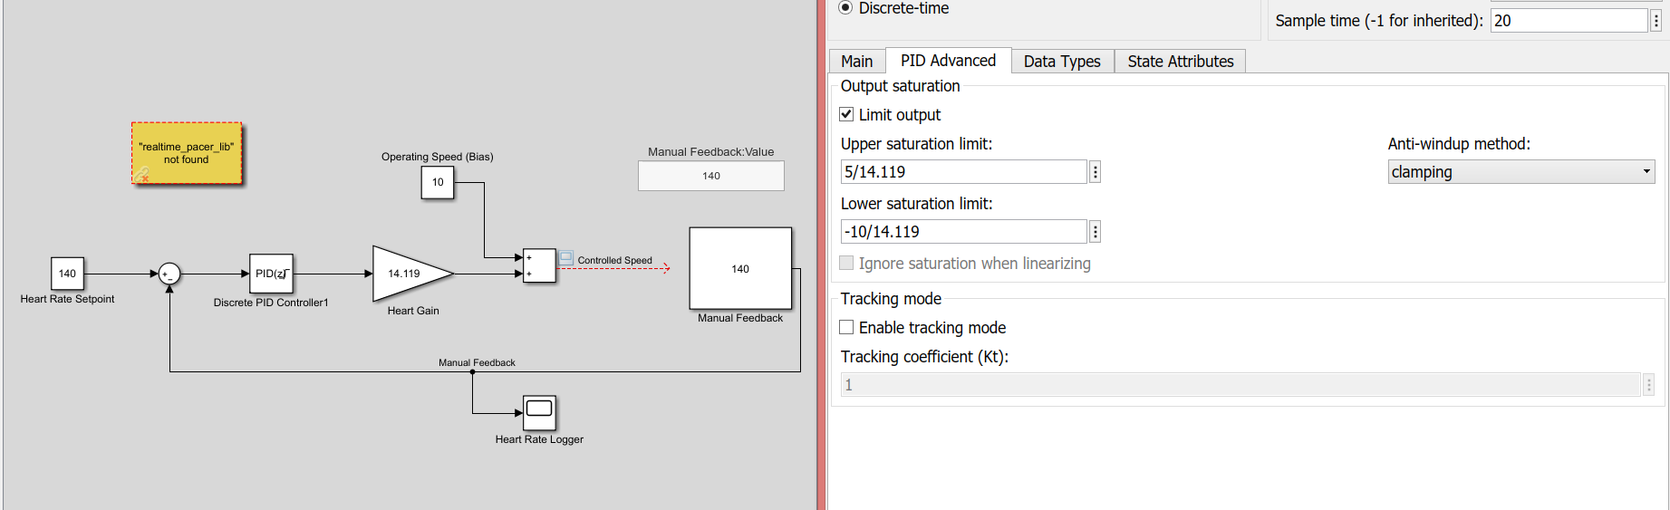

Figure …

1. Comment on the “Human in the Loop” method. What are the discrepancies with respect to the obtained runner heart model?

**ANSWERS**

2) Every person’s physiology is different since their genetics and received environmental interactions are unique. All these factors change the body development and result in different body structures. Therefore, every person has different heart characteristics and the model extracted from the heart is also different. To get an accurate model, the runner stays the same during the experiment. Otherwise, the model will be inaccurate and the designed controller may fail to complete its mission.

3) It chooses the initial parameters arbitrarily (when the “Auto” option is selected) then iteratively increases/decreases the parameters. In every iteration, it examines how the current response “fits” to the real data. It tries to maximize the “fit value”. In preliminary work, graphical FOPDT fit method is implemented. It doesn’t contain iterations and requires simple graphical measurements. It is useful when a computational tool such as MATLAB is not available.

4) Since the heart’s pulsing mechanism is nonlinear, the further we deviate from the chosen operating point, more changes in the model parameters occur.

5) The response has an overshoot. In low oxygen consumption cases (i.e. 5kph + 0 degree slope), the heart can easily response to the environmental changes. This condition results the heart to make an overshoot since the $\frac{Disturbance}{Main Oxygen Need}$ ratio is large. However, in high oxygen consumption cases (i.e. 10 kph + 15 degree slope) the oxygen need required to compansate the environmental effect is small with respect to main oxygen need. In other words, $\frac{Disturbance}{Main Oxygen Need}$ ratio is quite small. Therefore, in high speeds; the heart rate response doesn’t include any overshoot.

6) The discrete controller provides us the opportunity to update the heart rate value in a manual and discrete way. Since we don’t have a continuous communication system between the heart rate transmitter and the Simulink, the discrete controller is a right choice to use.

Advantage: The ease of implementation.

Disadvantage: Increased response time. Discreteness makes the controller to show partial ON-OFF like behaviors.

7)

8)